Curriculum Plan (ODD SEM 2024): B.Sc. (H) Mathematics I Year (Semester I)
Paper SEC: MATHEMATICAL MODELING WITH EXCEL
Dr. Tajender Kumar  Assistant Professor  Department of Mathematics  Kalindi College (University of Delhi)  Delhi- 110008  Mobile: +91 7417837644  E- mail: tajenderkumar@kalindi.du.ac.in |  | 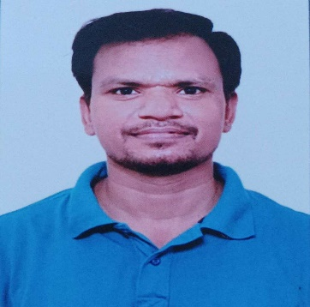 | Marks Distribution | Theory
 |  |  |  | Practical
 |  |  |  |  | Attendance 6 Marks
 |  |  | Classes Assigned | Practical | 4 Practical per week
References |  | - Albright, Brian, & Fox, William P. (2020). Mathematical Modeling with Excel (2nd ed.)
 | Week | Topics
 | Beginning/1st week with 3 days  (29-31 AUG, 02-07 SEP) | Discrete dynamical system concepts and examples;
 | 2nd week  (09-14 SEP) | Discrete dynamical system concepts and examples;
 | 3rd week  (16-21 SEP) | Long-term behavior and equilibria, Discrete log equation.  [1]: Chapter 4 (Sections 4.1 to 4.3).
 | 4th week  (23-28 SEP) | Long-term behavior and equilibria, Discrete log equation.  [1]: Chapter 4 (Sections 4.1 to 4.3).
 | 5th week  (30 SEP-05 OCT) | Linear predator-prey model,
 | 6th week  (07-12 OCT) | Linear predator-prey model,
 | 7th week  (14- 19 OCT) | SIR model of epidemics, and SIS model.
 | 8th week  (21-26 OCT) | SIR model of epidemics, and SIS model.  [1]: Chapter 4 (Sections 4.4, and 4.6).
 | 9th week  (04-09 NOV) | Monte Carlo simulation: Flipping a coin, Area under a curve,
 | 10th week  (11-16 NOV) | Monte Carlo simulation: Flipping a coin, Area under a curve,
 | 11th week  (18-23 NOV) | Car dealership contest, and the birthday problem.
 | 12th week  (25-30 NOV) | Car dealership contest, and the birthday problem.  [1]: Chapter 6 (Section 6.2), and Section 6.3 (Example 6.3.2 and Exercise 6.3.4 only).
 | 13th week  (02-07 DEC) | Revision
 | 14th week  (09-14 DEC) | Revision
 | 15th week  (16-21 DEC) | Revision
 | 16th week only with 1 Days  (23 DEC) | Revision
Dispersal of classes, preparation leave and practical examination begin- 24 December, 2024.

