Curriculum Plan: B. Sc. (Hons) Mathematics (Semester VI)- ADVANCED GROUP THEORY. (2024-25)-EVEN SEM
DR. ABHISHEK KR. SINGH  Assistant Professor  Department of Mathematics  Kalindi College  University of Delhi  Delhi- 110008  Mobile: +91-8375834510  E- mail: abhishek@kalindi.du.ac.in |  | 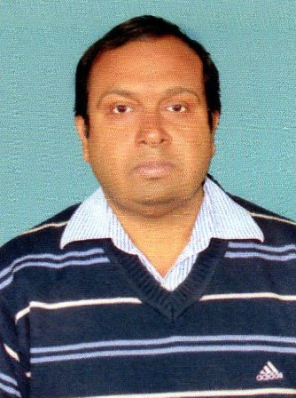 | Marks Distribution | Theory -90
 |  |  |  | Internal Assessment-30
 |  |  | Classes Assigned | Lectures: 3 per week
 | References | 1. JOSEPH A. GALLIAN (CONTEMPORARY ABSTRACT ALGEBRA) 4TH ED.  2. DUMMIT AND FOOTE (ABSTRACT ALGEBRA) 8TH ED.
 | Week | Topics
 | 1st week | GROUP ACTIONS AND PERMUTATION REPRESENTATION. Continued.
 | 2nd week | GROUP ACTIONS AND PERMUTATION REPRENTATION.
 | 3rd week | STABILIZERS AND KERNELS OF GROUP ACTIONS. Continued.
 | 4th week | STABILIZERS AND KERNELS OF GROUP ACTIONS.
 | 5th week | GROUP ACTING ON THEMSELVES BY LEFT MULTIPLICATIONS AND CONSEQUENCES. Continued.
 | 6th week | GROUP ACTING ON THEMSELVES BY LEFT MULTIPLICATIONS AND CONSEQUENCES.
 | 7th week | CONJUGACY IN Sn.
 | 8th week | SYLOW THEOREMS
 | 9th week | FINITE SIMPLE GROUPS
 | 10th week. | NONSIMPLICITY TESTS
 | 11th week | SOLVABLE GROUPS
 | 12th week | COMPOSITION SERIES
 | 13th week | NILPOTENT GROUPS
 | 14th week | JORDAN-HOLDER THEOREM
 | 15th week | REVISION.

