**CURRICULUM VITAE**

**Name:** Dr. Prerna Siwach

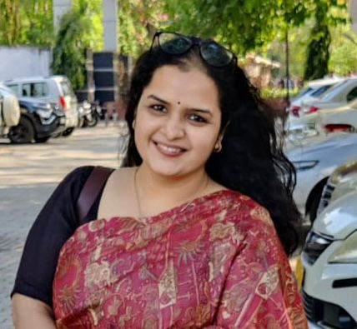

**Date of birth:** August 21st, 1990

**Sex:** Female

**Nationality:** Indian

**Designation**: Assistant Professor, Department of Geography, Kalindi College, University of Delhi.

**Contact:**

Department of Geography, Kalindi College,

University of Delhi, Delhi-110008.

Email Id: prernasiwach@kalindi.du.ac.in

Contact detail: 9999809365

**Current Address:**

Ld/133, sardar patel Appartment, Pitampura, New Delhi -110034.

**Permanent Addres**s:

Ld/133, sardar patel Appartment, Pitampura, New Delhi -110034.

**EDUCATIONAL QUALIFICATIONS**

**Ph.D.** in Geography from ***Department of Geography, Delhi School of Economics,* (University of Delhi),** 2016-2021.

Thesis titled**:** “**Fear of Violence and Gendered Access to Public Spaces: A Study of Urban Delhi”.**

**M.Phil**. in Geography from ***Department of Geography, Delhi School of Economics,* (University of Delhi)**, 2013 - 15.

**M.A.** in Geography from ***Department of Geography, Delhi School of Economics,* (University of Delhi)** 2011-2013**.**

**B.A.(H)** inGeographyfrom ***Miranda House,* (University of Delhi)**, 2008-2011.

**PUBLICATIONS**

**Journal Articles:**

* Siwach, P. and Tiwari, P. (2024). Gendering of Space Through Indian History: A Geographical Perspective **The Oriental Anthropologist**,. https://doi.org/10.1177/0972558X241277120
* Siwach, P. (2020). Mapping Gendered Spaces and Women’s Mobility: A Case Study of Mitathal Village, Haryana. **The Oriental Anthropologist**, 20(1), 33–48. https://doi.org/10.1177/0972558X20913680
* Siwach, P. and Malik, M. (2017) “Integrated Child Development Scheme in Delhi: An Evaluation of Social Welfare Schemes and Planning” in **International Journal of Research in Humanities & Soc. Sciences** Vol. 5, Issue: 6 June : 2017 (ISSN:(P) 2347-5404 )
* Siwach, P. and Malik, M. (2017) “Laadli Yojana in Delhi: A Critical Appraisal of Public Policy and Planning” in **International Journal of Research in Humanities & Soc. Sciences** Vol. 5, Issue: 5, May : 2017 (ISSN:(P) 2347-5404)

**TEACHING EXPERIENCE**

* Assistant Professor, Kalindi College, Universty of Delhi.November 21st, 2023 onwards.
* Assistant Professor, Department of Geography, Govt P.G College, Badli, Jhajjar, Haryana , August 2019 – November 2023.

**RESEARCH EXPERIENCE**

* UGC-NET SRF (Senior Research Fellow), University Grant Commission, Govt. of India, in Geography (2017-2019 )
* UGC-NET JRF (Junior Research Fellow), University Grant Commission, Govt. of India, in Geography (2015-2016 )

**SOFTWARE SKILLS**

ENVIVO, QGIS, MS Excel.

**LANGUAGE SKILLS**

English and Hindi

**RESEARCH INTERESTS**

Gender and Geography, Research Methodology and Field work, Social and Cultural Geography, Human Geography, Geographical Thought and Regional Planning and Development.

**HOBBIES AND OTHER INTERESTS**

Reading and Travelling

Name: Dr.Prerna Siwach

Date: 29-9-2024

Place: Delhi