Dr. Naghma Praween
Career Objective
To seek position as an assistant professor in a reputed college where I can use my knowledge and skills to guide students in their academic pursuit and expand my knowledge base in the process.
Brief Profile
- Taught the post-graduate classes in Botany Department at T. M. Bhagalpur University (2014 to 2015)
- Conducted extensive Research in the field of Botany (particularly, Plant Physiology & Biochemistry)
- Published Research Papers on various topics in Plant Physiology & Biochemistry
- Awarded Maulana Azad National Fellowship by University Grant Commission in 2010
Work Experience
- Botany Department, Tilka Manjhi Bhagalpur University (2014 to 2015)
- Shivaji College: As Ad-hoc Assistant Professor (2017)
- Kalindi College: As Ad-hoc Assistant Professor (2018-2023)

Designation: Ad-hoc Assistant Professor

Job Responsibilities:
- Conducting Post Graduate classes in Botany (Plant Physiology & Biochemistry)
- Supervising lab work of students and guiding students in conducting practical
- Maintaining students’ attendance and assignment record
- Interacting with students to understand and resolve their curricular and co-curricular problems

Education
- Ph.D. from Tilka Manjhi Bhagalpur University (2016)
- M.Sc. in Botany from Tilka Manjhi Bhagalpur University (2002)
  - Specialization in Plant Physiology & Biochemistry
- B.Sc. from Muslim Minority College, Bhagalpur (1999)

Achievements
- Awarded Maulana Azad National Fellowship by University Grant Commission in 2010.
- Appointed as a member of the paper “Ethnobotany” for the end semester examinations to be held in December, 2020.
- Appointed as a member of the paper “Medicinal Botany” (CBCS) for the end semester examinations to be held in May, 2021.
- Appointed as the external examiner in the Department of Botany, SGTB Khalsa College to conduct the practical exam in B.Sc LS for Cell & Molecular Biology conducted in 14.11.19.
- Appointed as the external examiner for B.Sc LS for Cell & Molecular Biology examination held on 16.11.22 at 9 AM at Zakir Hussain Delhi College Center.
- Appreciate the contribution of Dr Naghma Praween of Kalindi College for Women for the timely evaluation of answer scripts of Open Book Examination (OBE) held in March, 2021.
- Appreciate the contribution of Dr. NAGHMA PRAWEEN of Kalindi College for Women for the timely evaluation of answer scripts of Open Book Examination (OBE) held in Nov-Dec, 2021.
- Participated in the Online Workshop on “Variants of PCR and its Application" from 22nd to 24th of October, 2021, Organized by CytoGene Research & Development, Lucknow.
- Convener of Biochemical Society (Biocenosis) in 2023.
- Co- Convener for Science Courses of Time- Table Committee in 2023.
- Member of Disaster Management Cell in 2022.
- Member of Student Feedback Committee in 2022-2023.
- Members of Prospectus Committee.
- Invitation for Judge (internal) the event held on 11th Feb 2023. Geography Department of Kalindi College is celebrating its Annual Geo Fest “RESURGENCE 2023” on the topic “Climate Change : sinking domains of nature ( a light on joshimath event)” on 10th & 11th Feb, 2023 at 10.00 a.m onwards.

Publication Profile: Research Papers Published in Journals
- Praween N, and Singh A.K. (2014). Effect of Kinetin on protein concentration of Makhana ( Euryale ferox Salisb.) During fruit Development. International Journal of Basic & Applied Science Research 1:06 – 11 (2014).
- Praween N. and Singh A.K. (2013). Effect of Gibberellic Acid on Anthocyanin Separation in Impatiens balsamina. Sciencia vol.1 (Issue–1).
- Praween N et al.( 2015). Estimation of Starch Content in the Treated Perisperm of Euryale ferox Salisb. ( Makhana) Due to Polymonial Regression Fit Equation. International Journal of Recent Scientific Research, 6(9) pp.6000-6003.
- Naghma Praween and Arun K. Singh (2015). Effect of Kinetin on Protein Content of Euryale ferox Salisb. ( Makhana) During Fruit Development. Hortflora Research Spectrum, 4 (2): 150- 154.
- J. Aparajita, Arun kumar singh, U.K Chauhan, Naghma Praween, Dharmendra kumar. (2014). Pharmacological Evaluation for the Presence of Total Sugar in the Leaves of Catharanthous Roseous. Pharma Science Monitor 5(2), 69-72.
- J. Aparajita, U.K Chauhan, Arun kumar singh, Dharmendra kumar, Naghma Praween.( 2014). Pharmacological Evaluation For The Presence of Protein in The Leaves of Catharanthous Roseous . Pharma Science Monitor 5(2), 50-52.
- Naghma Praween, Arun Kumar Singh & Jhanvi Aprajita. (2014). Makhana – A Hope of New Entrepreneurship. Journal of Regional Studies vol. 25, No. 49-50.
- Praween N et al. (2015). Estimation of Protein in Gibberellins Treated Perisperm of Euryale ferox Salisbs. (Makhana) by Polynomial Regression. International Journal of Basic & Applied of Science Research, 2(2); 169-174.
- Praween N, Chaudhary S.K. (2016). Estimation of Sugar Content by the Effect of Gibberellins in the Perisperm of Euryale ferox Salisbs. (Makhana) Due to Polynomial Regression Fit Equation. IOSR Journal of Pharmacy, 6(10); 07-10.
Conference and Seminars Attended and FDP
- UGC Sponsored National Seminar on Glimpses of Phytopathology for Sustainable Agriculture (March 27- 28, 2012) Organized by: T.N.B. College , Bhagalpur & Univ. Depart. Of Botany.
- 6th Bihar Science Conference 2014 held at Magadh Mahila College , Patna ( Under Patna University , Patna ) , from 23rd to 25th December, 2014 and presented her research entitled “Biochemical Analysis of Protein in the treated seeds of antioxidant plant Euryale ferox Salisbs. For different energy level’s’’ Organized by BBrains Development Society & Magadh Mahila College.
- National Seminar cum Workshop On Prospect of Biotechnology and Bioinformatics Tools & Their Application ( 19th – 21st ) Jan., 2015 , Sponsored by DBT, Ministry of Science & Technology, Govt. Of India and UGC during 19th – 21st Jan. 2015.
- UGC Sponsored National Seminar on Ethno botany : Challenges and Future Prospect Organized by P.G department of Botany , S.K.M. University , Dumka, held at Dumka, Jharkhand, India on 30th and 31st March 2012.
- National Workshop on Practices & Tools of Biodiversity Conservation in Protected Areas held at University Department of Botany, T.M. Bhagalpur University, Sponsored by UGC, New Delhi during 24-25 November, 2015.
- TMBU, DST&CSIR Sponsored International Conference on ‘The Recent Trends In Biotechnology and Biodiversity’ Organized by: Departments of Botany and Zoology on 27th – 29th July, 2015.
- Two Week (Online) Interdisciplinary Faculty Development Programme on ‘MOOC's, E-Content Development, Research Methodology and Statistical Tools in Open Education World ’(3rd August – 17th August 2021) organised by Kalindi College, University of Delhi in collaboration with Mahatma Hansraj Faculty Development Centre Hansraj College, University of Delhi.
- Participated in One Day (Online) Workshop on “How to Catch Fake/Cloned/ Predatory Journals in Academics” (16th October, 2021) organised by Mahatma Hansraj Faculty Development Centre Hansraj College, University of Delhi
- Participated in the live webinar organized by the Phytomics: The Botanical society of Bhaskaracharya College of Applied Sciences (University of Delhi), held on 16th May 2020.
- Participation in ‘EDU-KUBOT- 3.0’ A National Web Series-cum-Training Programme on the topic “Tree Communications in the Forests” held on June 22nd , 2020.
- Participated in webinar on “Art and Science of Mentoring” lectured by Dr. Pratibha Jolly (FNASc, FInstP (UK), Academic Consultant NAAC, former Principal, Miranda House, University of Delhi) organised by Physics Department, Daulat Ram College, on June 1, 2020.
- COMPLETION OF HANDS-ON TRAINING SESSION ON E-Content Development using Basic Tools Organized by : E- Content Development Committee, Kalindi College, University of Delhi on 27th September, 2021.
Personal Details

- Name: Dr. Naghma Praween
- Date of Birth: March 1, 1979
- Marital Status: Married
- Citizenship: Indian
- Languages Known: English and Hindi
- Mobile: +91-7292057513; +91-9540057513
- E-mail: naghmaeuryale@gmail.com
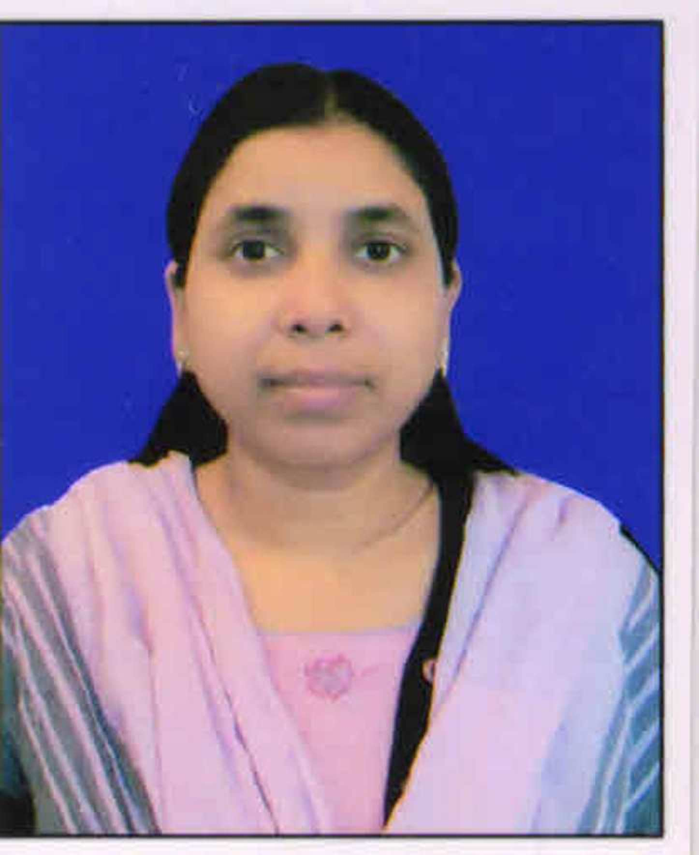
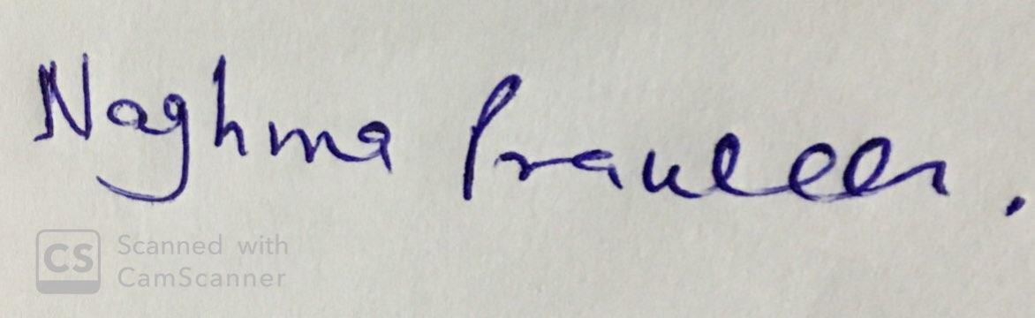
(Dr. Naghma Praween)
Date: 18__/_04_/_2023___
Place: Delhi

